[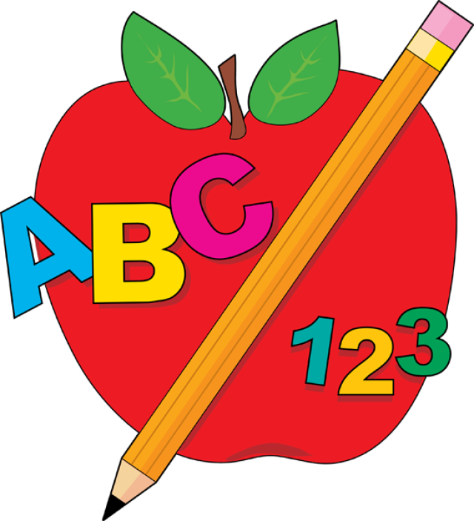](https://www.google.com/url?sa=i&rct=j&q=&esrc=s&source=images&cd=&ved=2ahUKEwjp7Z-B9LDdAhVQuFMKHUlvCV0QjRx6BAgBEAU&url=https://www.pinterest.com/pin/508695720394001986/&psig=AOvVaw3ZqJxywgmfq0Mx5DC_eIxO&ust=1536685026970269) 1st Grade Newsletter [](https://www.google.com/url?sa=i&rct=j&q=&esrc=s&source=images&cd=&ved=2ahUKEwix-9HJ87DdAhXFylMKHbDaC70QjRx6BAgBEAU&url=http://shopforclipart.com/clipart/helping-hands-clipart-14.htm&psig=AOvVaw1IMc2dGzRosVLIw4JmGlAi&ust=1536684914300581)

September 17th, 2018

Fabulous in First

**Important Dates:**

* 9/24- Grandparents Night from 6-7:30
* 9/26- Dairy Queen PTO Night

# What’s Going on in Class?

Math: Introduction to subtraction by finding the missing part.

Reading: Identifying text features in non-fiction texts

Phonics: short e

Grammar: adjectives

Science: Looking at weather patterns

**High Attendance Week**

**Monday: Super Hero Shirt Day**

**Tuesday: Twin Day (match another person)**

**Wednesday: Wear Neon Colors**

**Thursday: Sports Team Day**

**Friday: Conkwright Day**

**Snack**

[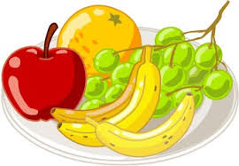](https://www.google.com/url?sa=i&rct=j&q=&esrc=s&source=images&cd=&cad=rja&uact=8&ved=&url=http%3A%2F%2Fworldartsme.com%2Fhealthy-snack-time-clipart.html&psig=AOvVaw3JaN5WirsqaaItCozGR8k0&ust=1537229806219933)Students may bring a healthy snack from home to eat each afternoon. Please avoid foods with peanut/tree nuts.

Spelling Words Sight Words

1. Leg my
2. Yet all
3. Hen here
4. Web does
5. Pen who
6. Wet me
7. Best
8. Next
9. Vest
10. Rest

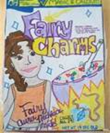

Headphones Needed

Our class is in need of a class set of over the ear wire headphones. We do a lot of work on computers through programs such as lexia for reading and dreambox for math. Please do not send in earbuds as students often complain about them not staying in their ears. Please send a pair in for your child as soon as possible. Thank you for all that you do to help our children be successful!

**Agenda’s**

Remember to check your child’s agenda each night for daily behavior reports. Folders should be checked each night as well so you can see the work your child is doing in the classroom as well important notes that may be sent home. 😊

Fabulous in Fourth